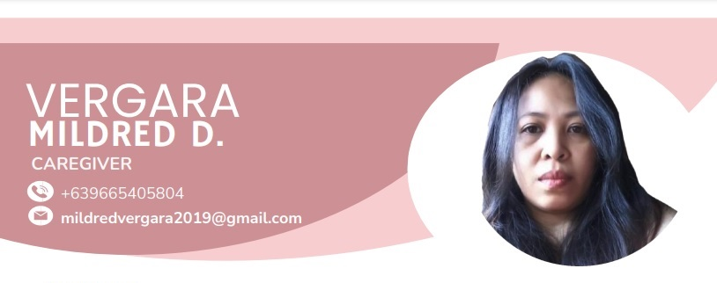**OBJECTIVE**

To secure a position within an established company where my skills and experience will be utilized and opportunities for future advancement.

**QUALIFICATION SKILLS**

• Knowledgeable, trained, and experienced in caregiving.

• Basic knowledge of Cookery.

**EXPERIENCE**

CAREGIVER

Home Base Setting

Mrs. Eden Lim

San Fernando City, La Union

Feb.16 to present

Patient Case: Stroke, fracture left pelvic, NGT feeding and dementia.

CAREGIVER

Home Base Setting

Mrs. Shiela Dacanay

Lingsat, San Fernando City, La Union

Dec.17 to Feb.08’23

Patient Case: Stroke, tracheostomy, suction, NGT feeding, foley catheter, bedsore stage 3 and ventilator machine.

CAREGIVER

Home Base Setting

Mrs. Karen Chiuco

San Jose Balanga City, Bataan

July 13 to August 23’22

Patient Case: Comatose, Stroke, tracheostomy, suction, and NGT feeding

CAREGIVER

Home Base Setting

Atty. Teresa R. Tam-Yap

Quezon City, Manila

March 22, 2021 to November 20, 2021

Patient Case: Stroke, tracheostomy, suction, tube feeding, and supra pubic catheter.

CAREGIVER

Home Base Setting

Mrs. Mirzi Dy Hianto Lao

Sta. Cruz, Recto, Manila

March 14 to 25, 2020

Patient Case: Stroke, tracheostomy, suction, NGT feeding, foley catheter and stage 4 bedsore.

CAREGIVER

Home Base Setting

Mrs. Veronica Dilegman

Pag-asa, Bagac, Bataan

Patient Case: Stroke, fracture left pelvic, NGT feeding and suction

**DUTIES AND RESPONSIBILITIES**

• Assists client with medication as defined in medication procedure

• Maintains a clean, safe, and orderly environment for the residents

• Assists client with activities of daily living, including bathing, dressing, grooming, toileting, transferring and getting to and from activities and meals according to the individual service plan.

• Monitoring and reporting changes in health, behavior, and needs.

• Following a prescribed healthcare plan, may include assisting with exercise and administering medication.

**ON THE JOB TRAINING ATTENDED**

Orani District Hospital

Maria fe, Orani, Bataan

August 27 to September 01, 2019

Rural Health Unit

San Jose, Balanga City of Bataan

September 02 to 06, 2019

Bahay Puso

Balanga City of Bataan

September 16 to 20, 2019

Mariveles Mental Hospital

Bonifacio St., Mariveles, Bataan

September 30 to October 04, 2019

**Educational Background**

**College:** Bataan Polly technic State University

Course: BSIT/Garments

Undergraduate

**Vocational**: Caregiver

School: Philippines Women University

March 20, 2019 to October 4, 2019

**Secondary**: Limay High School

March 31, 2000

**Primary**: Batangas-II Elementary School

April 7, 1997

**Personal Information**

Date of Birth: January 06, 1984

Nationality : Filipino

Civil Status : Single

Height : 5’0

Passport No.EC47857522

I hereby certify that the above information is true and correct to the best of my knowledge and belief.

MILDRED D. VERGARA

Applicant’s Signature